Report of the 5th CFD Project

(CFD4012P05)

Submitted to: Dr. M. Pourbagian

Submitted by: Arshia Saffari

Spring of 2023

Contents

CAD Design 3

Drawing 3

Generating Surfaces 6

Middle Part 7

Analysis 11

Importing model 11

Mesh 11

Solve 14

1st Run 14

2nd Run 15

Third run + 2nd mesh 17

Project Questions 21

# CAD Design

A 3D model is designed to be analyzed. CATIA is used in this project as it’s widely used in aerospace and other industries where CFD calculations are required. The model is parametric and 3D models can be generated just by entering design parameters.

### Drawing

In order to make the drawing as scalable as possible, so it can be modified easily later, four main design parameters are defined:

MainPipeDiameter = 4 in

TurnAngle = 90 deg

InletPipeDiameter = 1 in

InletPipeOffset = 0 in

The default values above are based on the sketch in figure 1.

Using these parameters means that the sketch doesn’t need to be changed if changing these parameters can produce desired output.

This approach also can easily generate geometries using CATIA API (Microsoft COM with Python, C++, C#, etc.) which combined with Ansys Parametric Design Language (APDL) can automatically optimize the design based on predefined performance index.

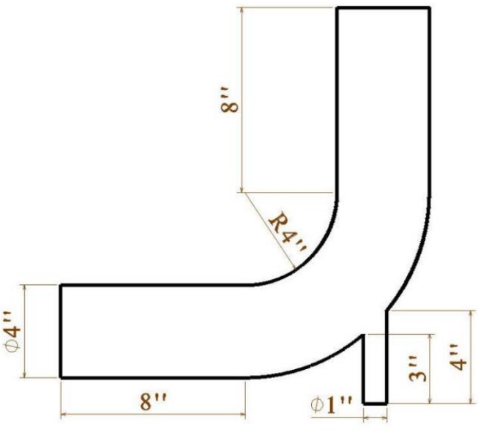

Figure 1. Problem Sketch.

Opening a CATIA V5 instant creates a new product. Using File -> new… a new part is generated under that product in the tree.

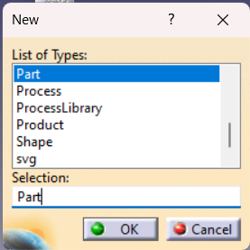

Figure 2. New Window.

The length unit can be changed to inch as dimensions are given in inches.

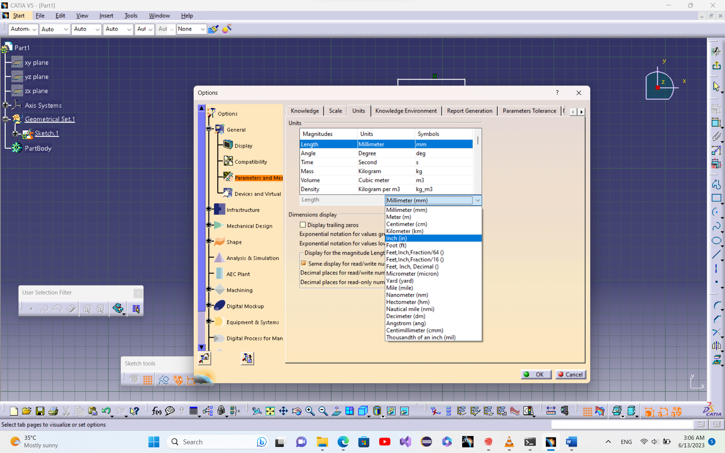

Figure 3. Sketch Units.

Changing workbench to GSD (Generative Shape Design), a rough sketch can be drawn.

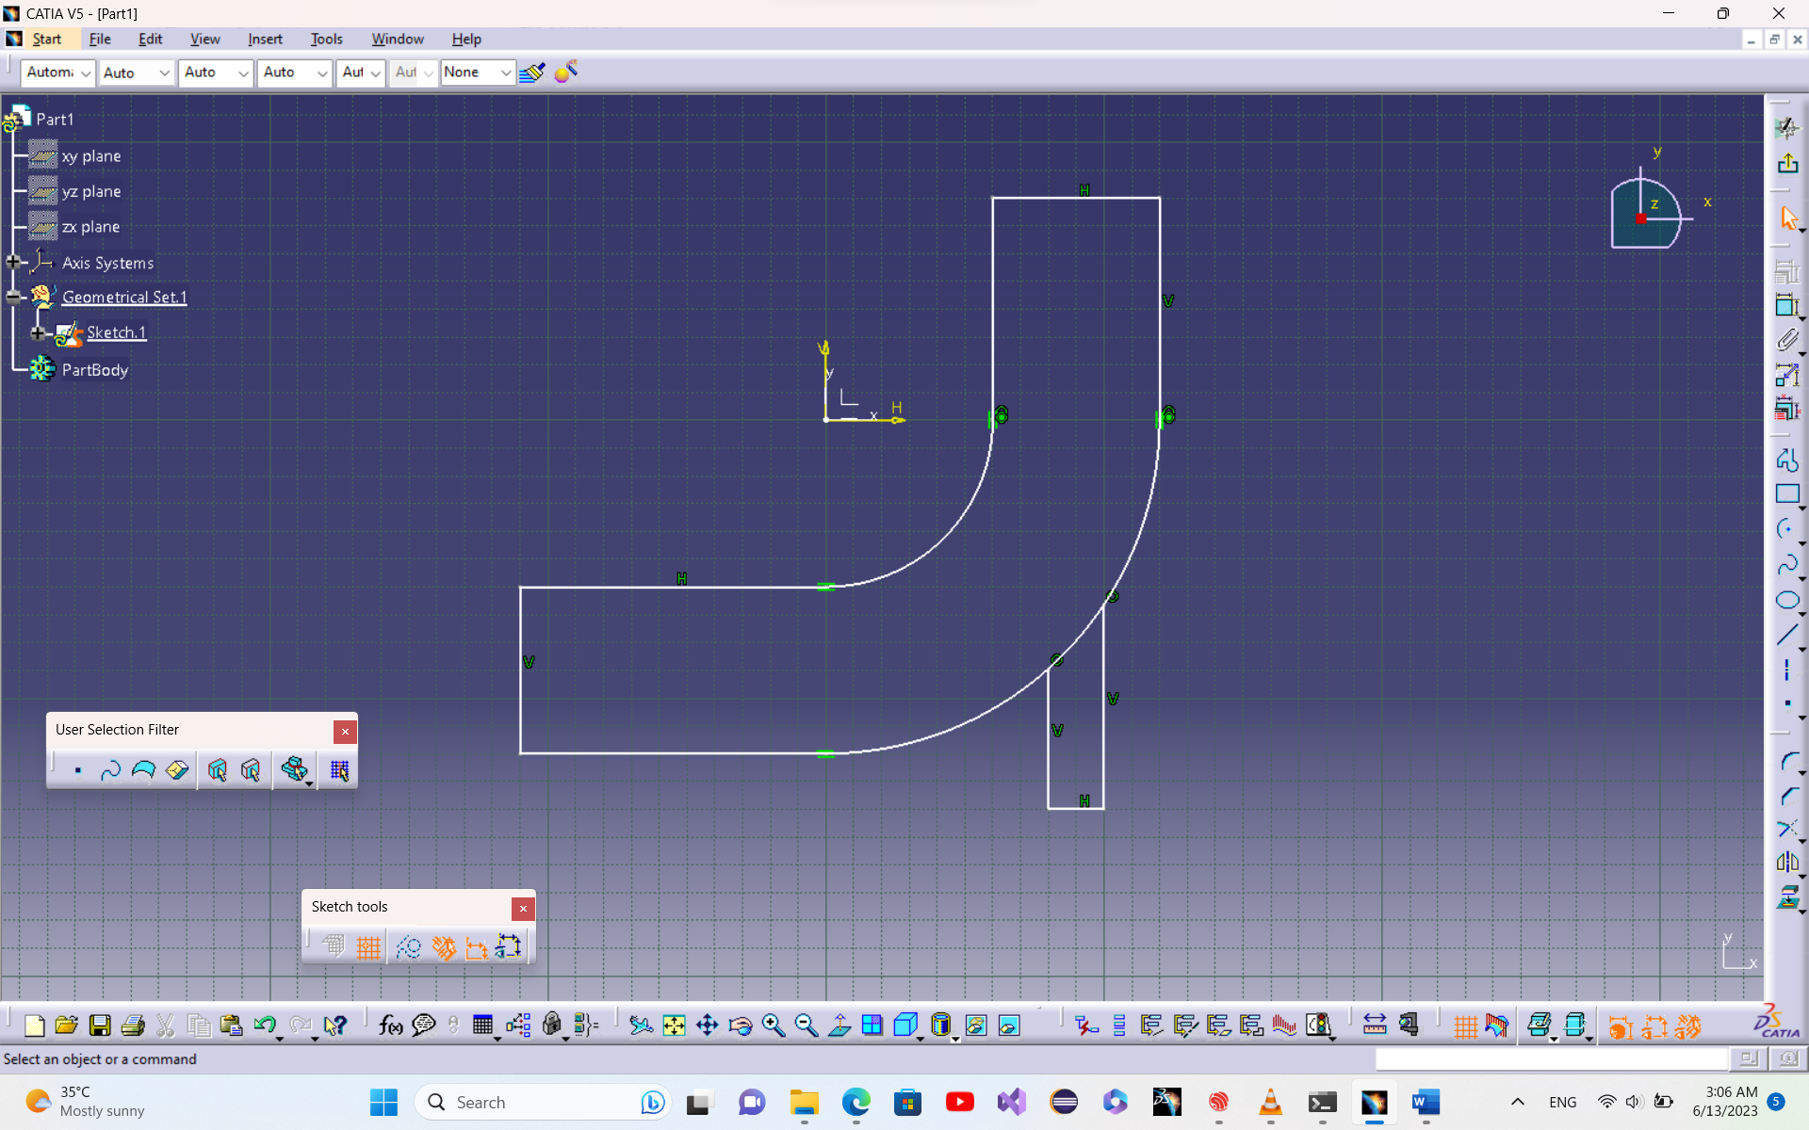

Figure 4. Rough sketch.

Using formulas, all parameters are defined as illustrated below.

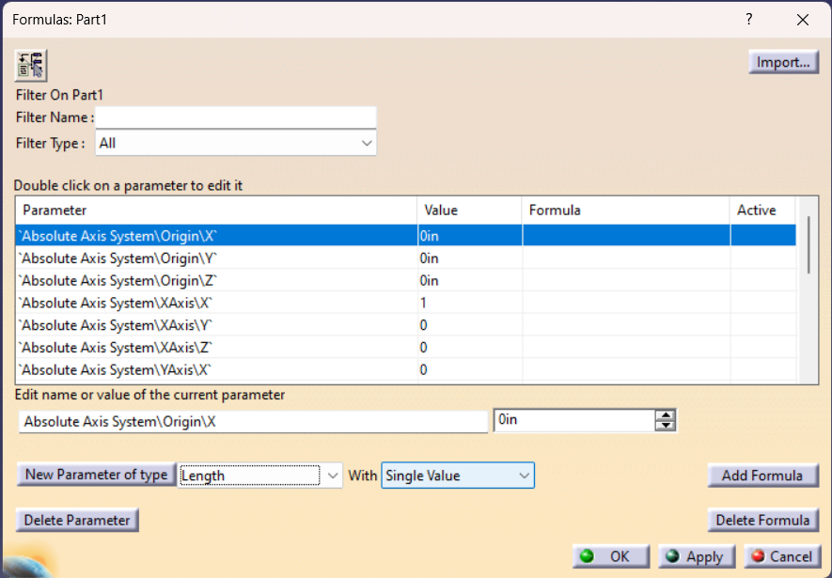

Figure 5. Formulas window with no user-defined parameters.

Changing type to “Length” and keeping the “Single Value”, 3 length parameters and 1 angle parameter is defined.

The parameters’ names and value can be changed by clicking on the parameter can editing the two line edits below the table.

Changes are made after pressing “Apply” button.

The final table is shown in figure below.

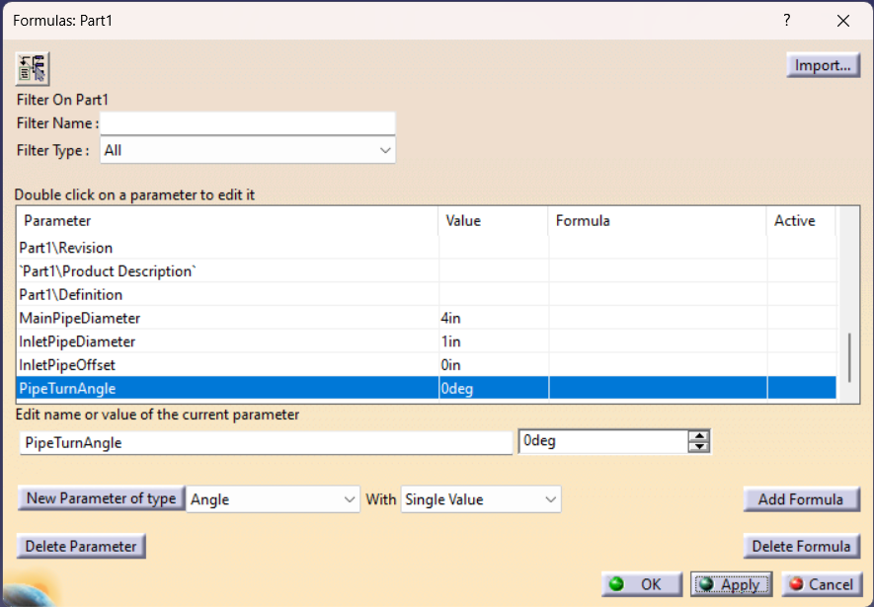

Figure 6. Formulas window with all parameters defined.

The sketch is dimensioned and the formulas are inserted.

To link dimensions with formulas, open the formula window, click on the constraint and double-click on the formula field in the same row.

The previously defined parameters are located in Parameters -> Renamed parameters

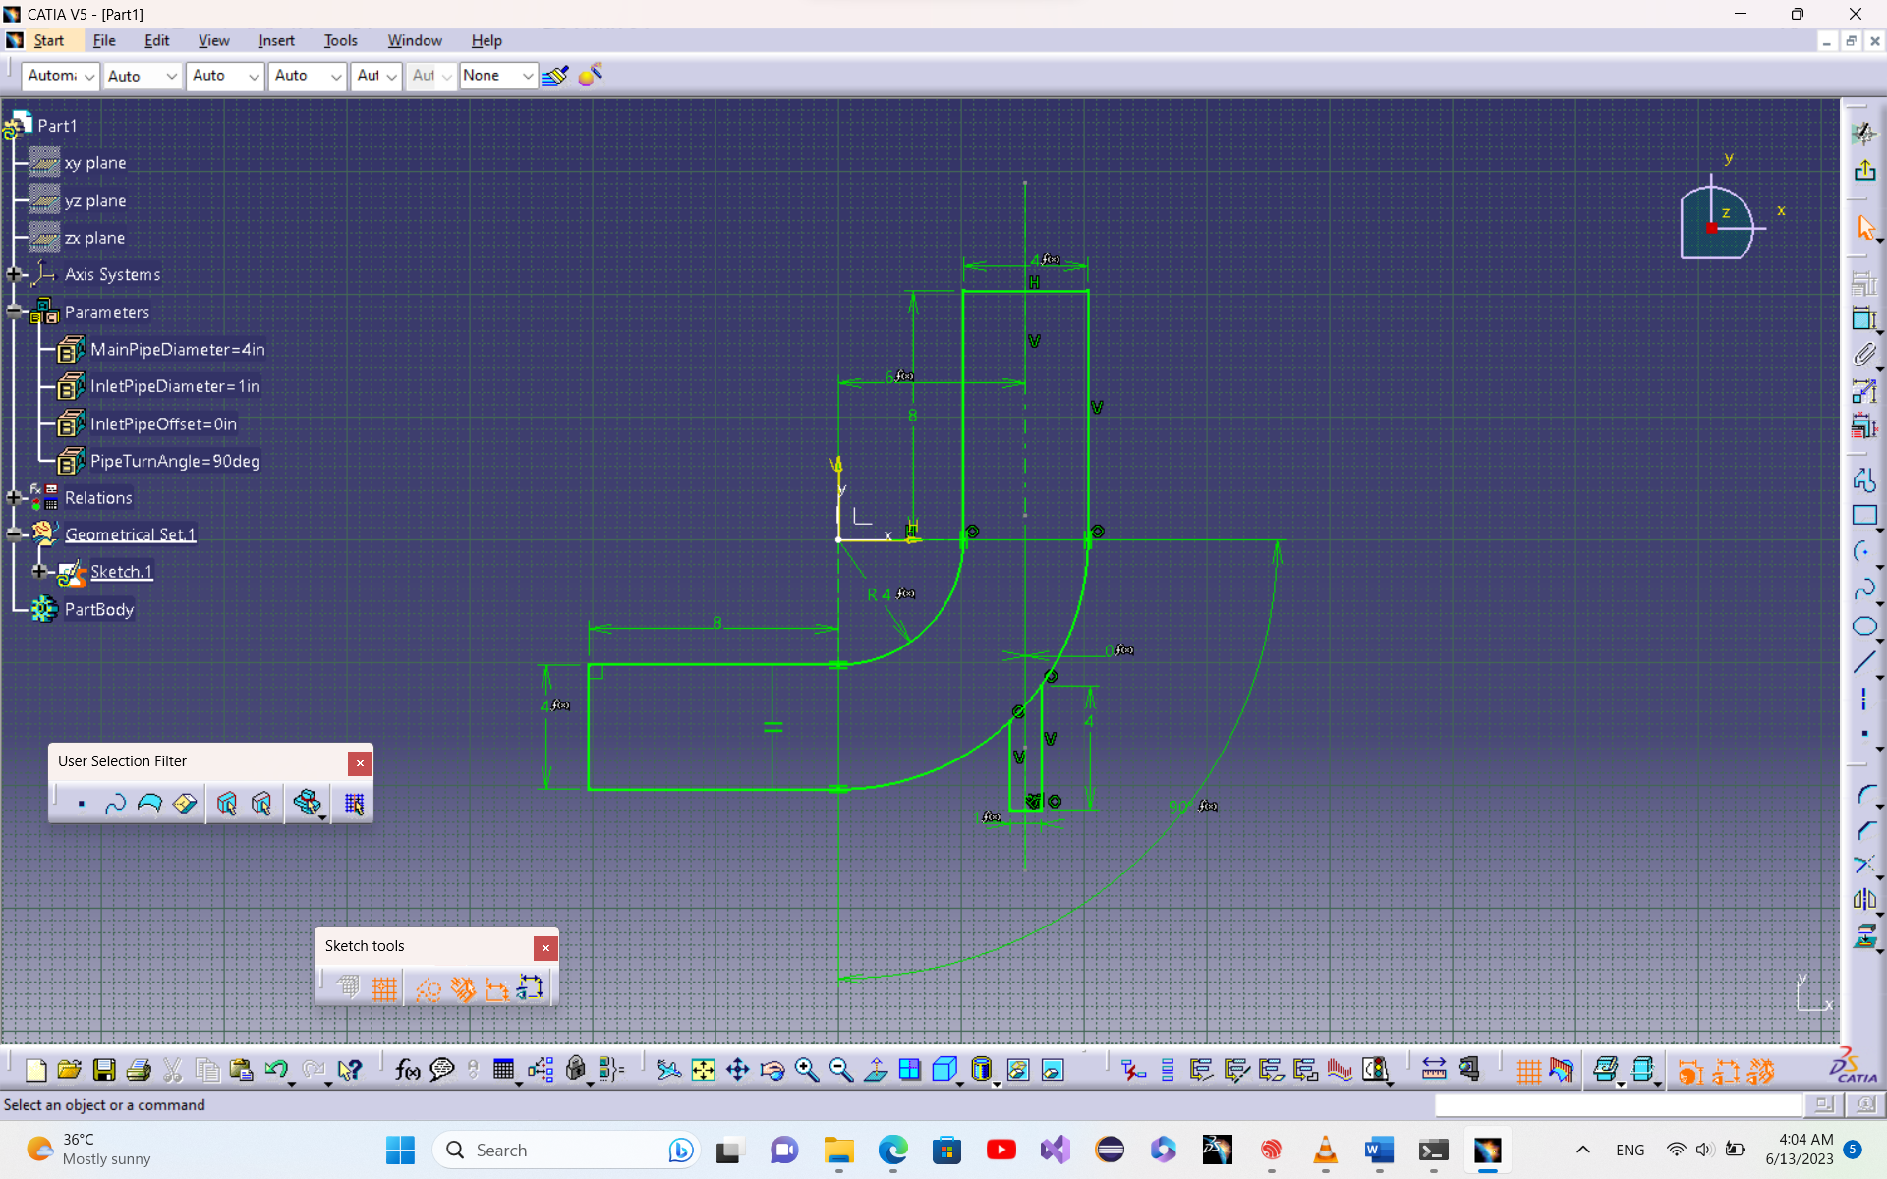

Figure 7. Final sketch.

### Generating Surfaces

The main body can be generated using revolute.

In order to select a subset of the sketch, “Create Extract” command is used. This command can be run in the same menu by right clicking on the field and selecting “Create Extract” or “Create Multiple Extract” options. Then in the “Extract Definition” window, elements inside sketch can be selected.

Revolute axis should be defined. By right clicking on the “Revolute axis” field and selecting “Create Line” command, the “Line Definition” window is opened. Using “Point-Direction” option, and creating point between the two points in a similar manner the revolute command can be performed.

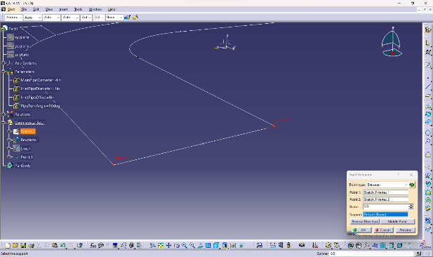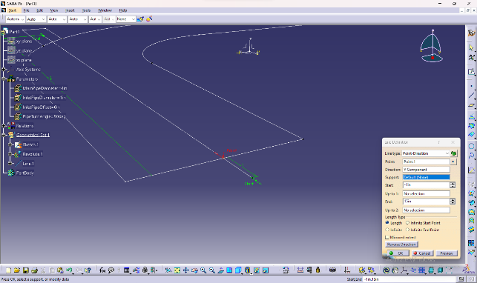

Figure 8. Point definition window of the revolute axis. Figure 9. Line definition window of the revolute axis.

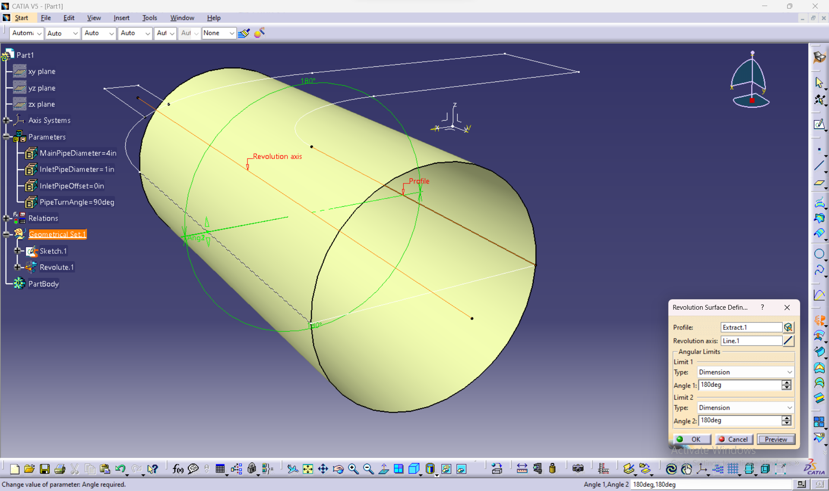

Figure 10. Revolute definition window of the main pipe.

The outlet and inlet sides are also generated in the same manner but the revolute axis of the outlet is parallel to the profile line.

### Middle Part

The middle Surface is created as illustrated in figure below.

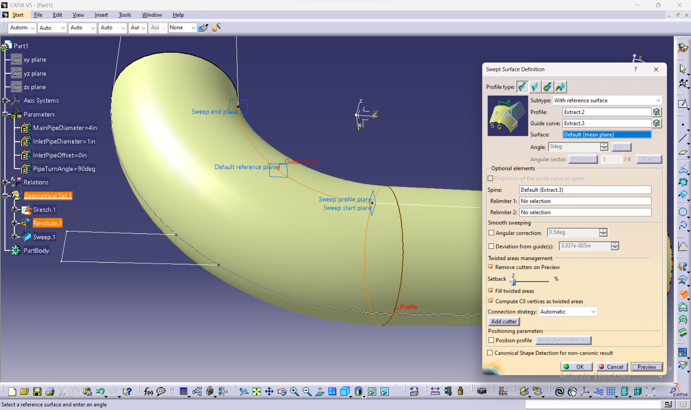

Figure 11. Sweep definition

Trimming the inlet pipe at intersection line to the main pipe:

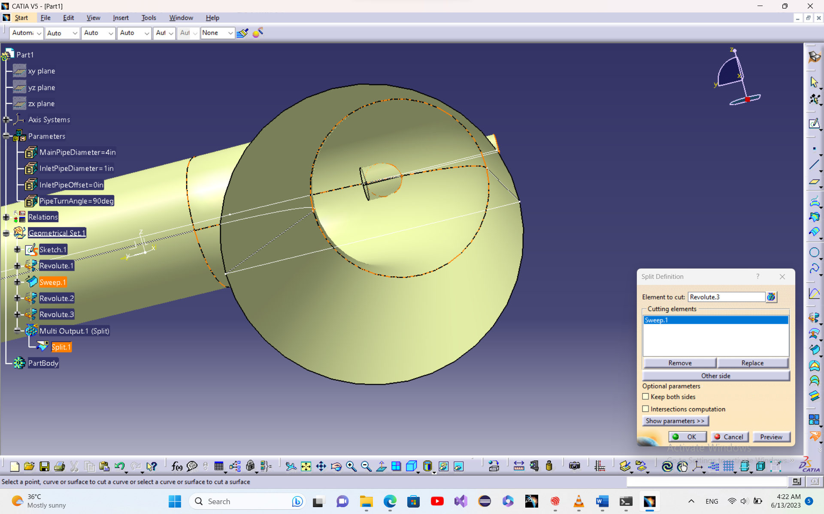

Figure 12. Split definition

The final product:

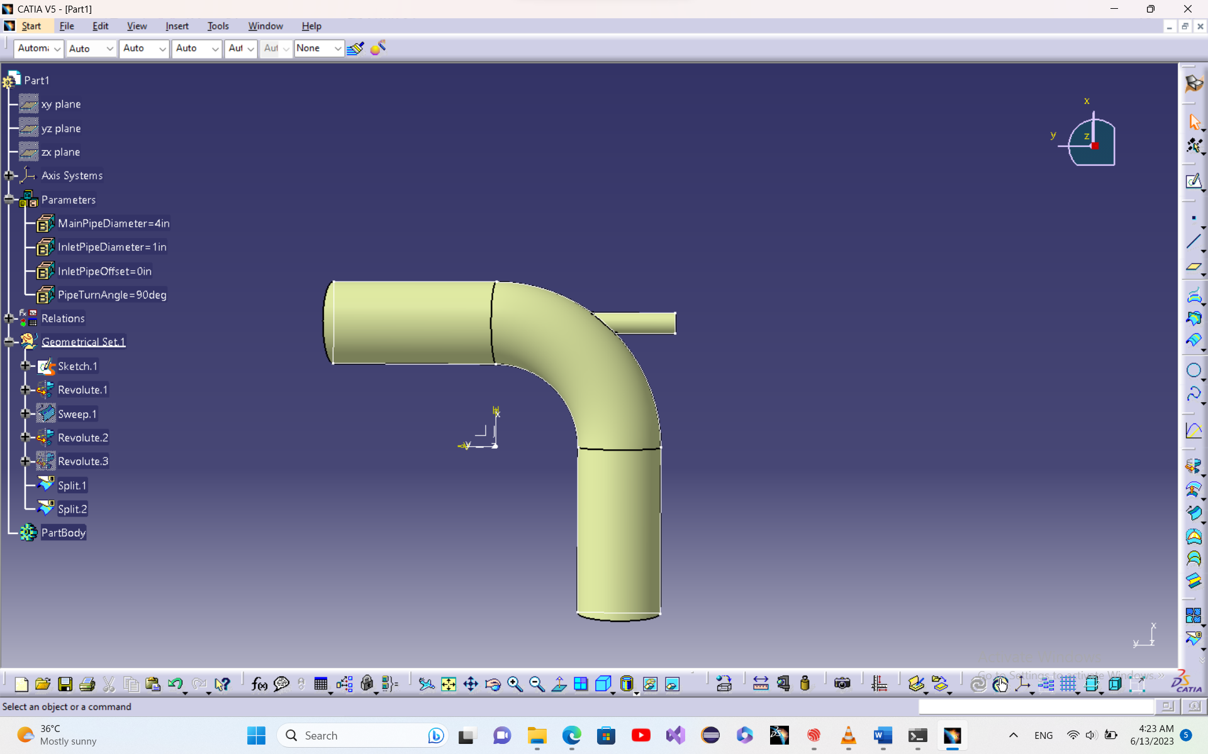

Figure 13. Final complete surface

Using different parameters:

“PipeTurnAngle” = 75 deg

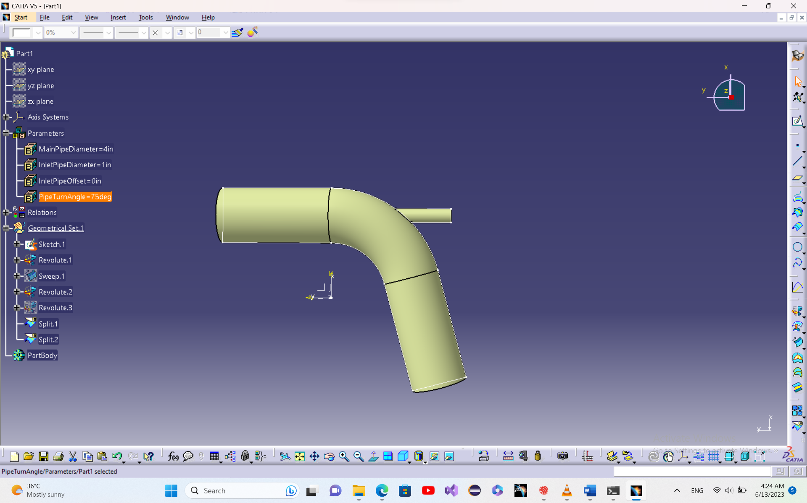

Figure 14. Final surface with PipeTurnAngle = 75 deg

“InletPipeOffset” = 1 in.

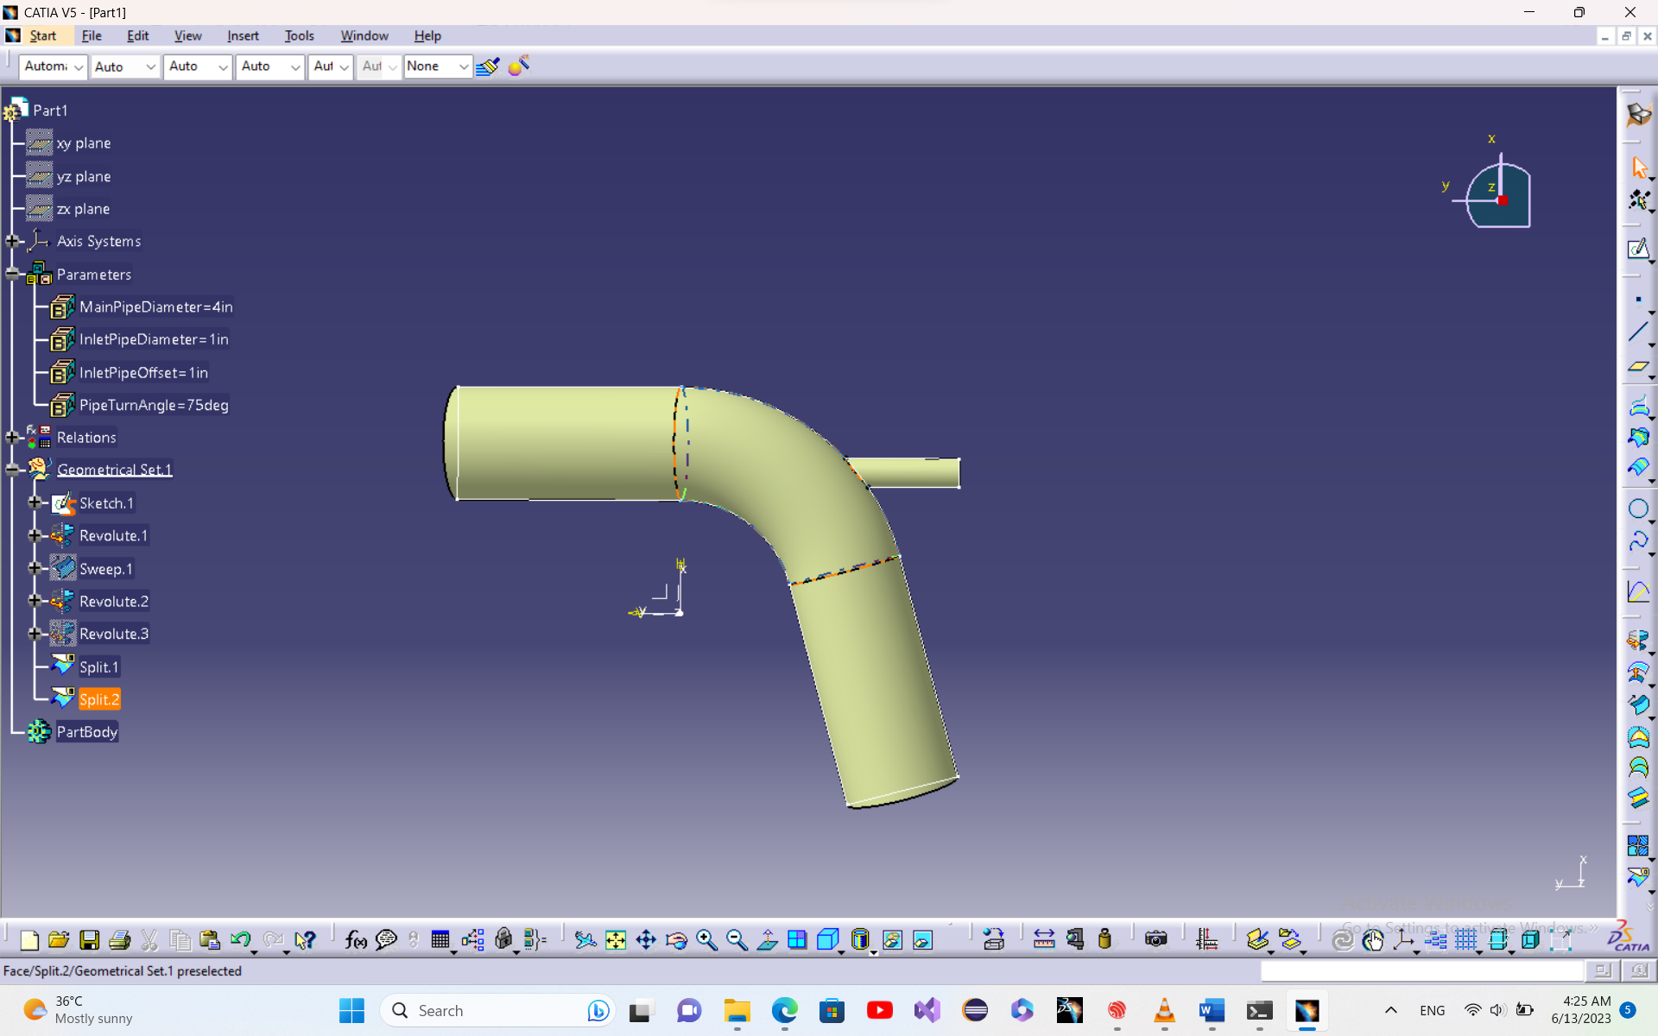

Figure 15. Final surface with PipeTurnAngle = 75 deg and InletPipeOffset = 1 in.

Joining all surfaces together, the hole pipe can be split using the “XY Plane” as cutting element.

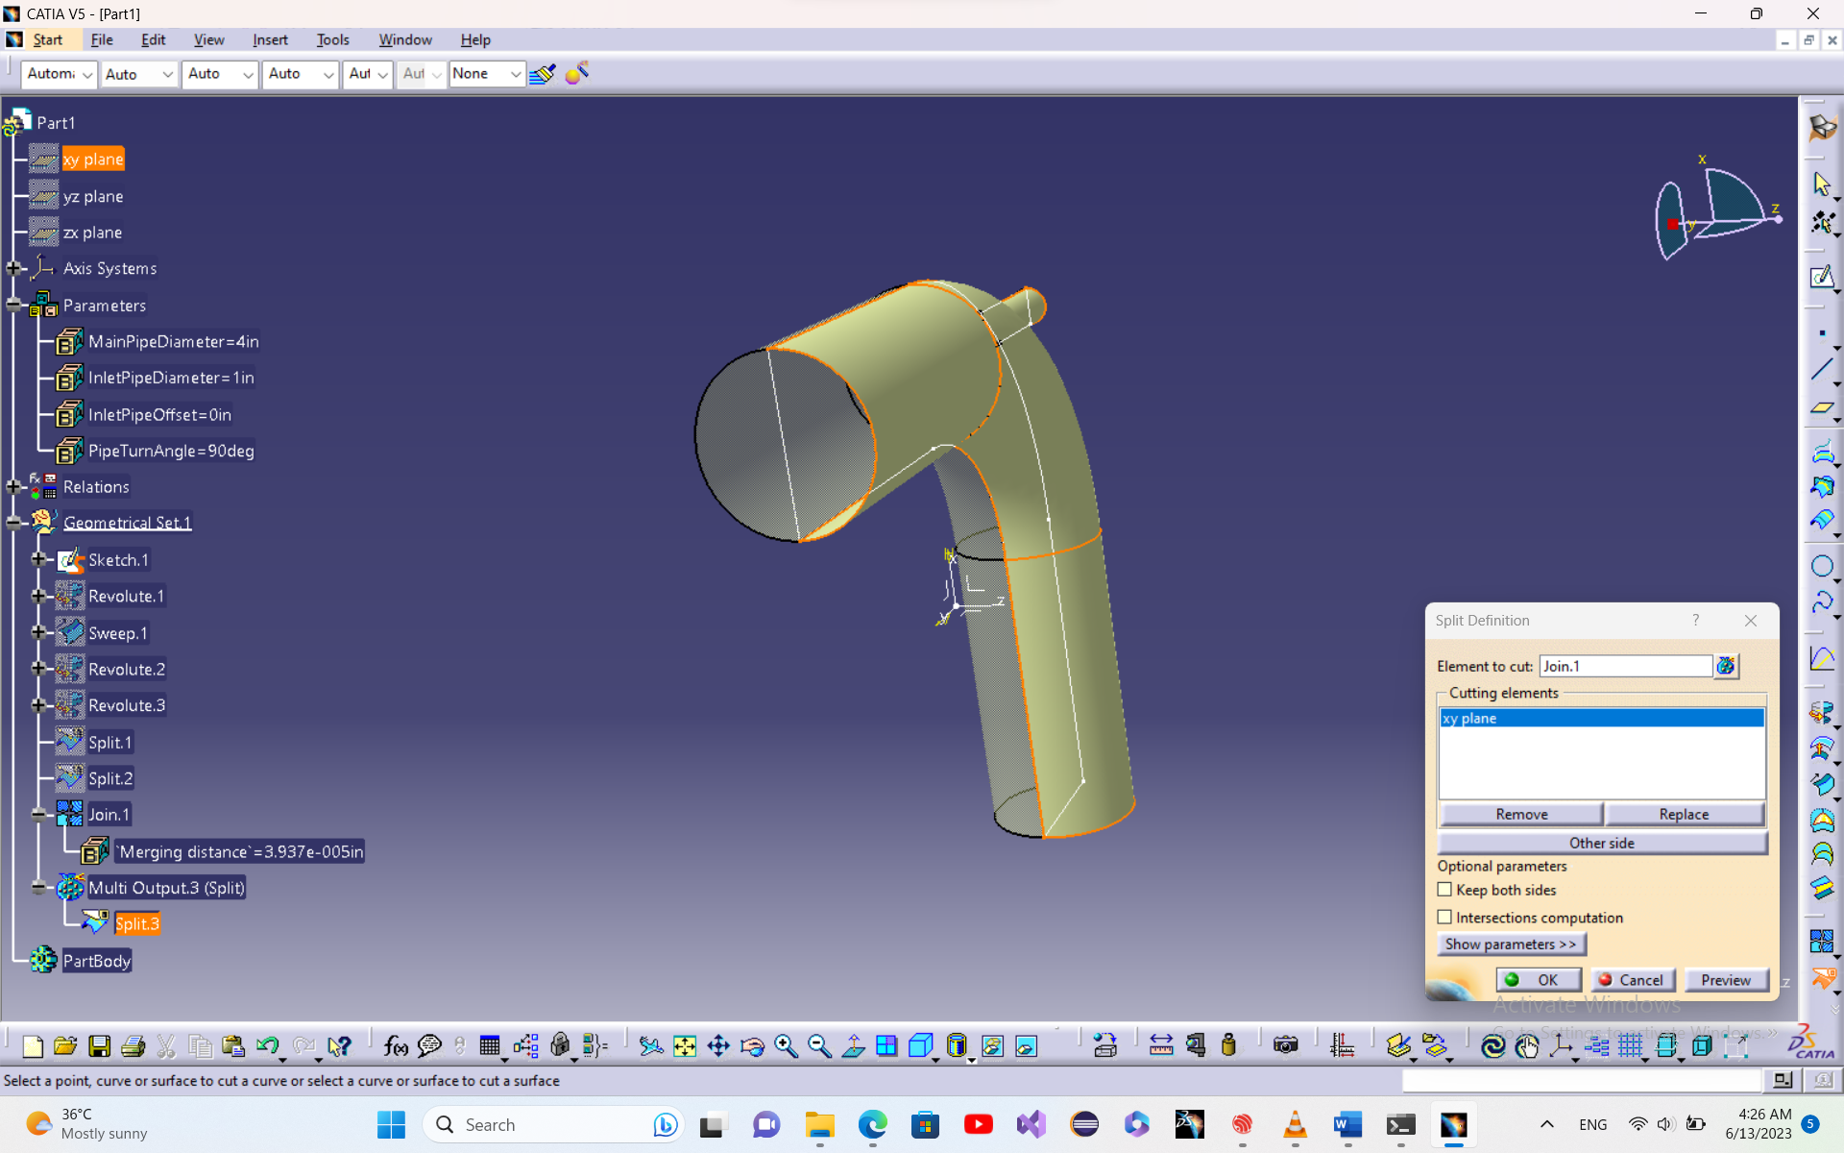

Figure 16. Split definition

Closing other surfaces:

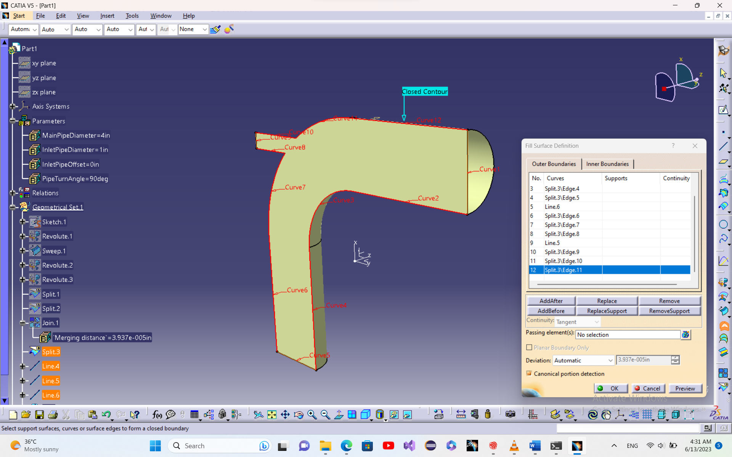

Figure 17. Fill definition

Final design:

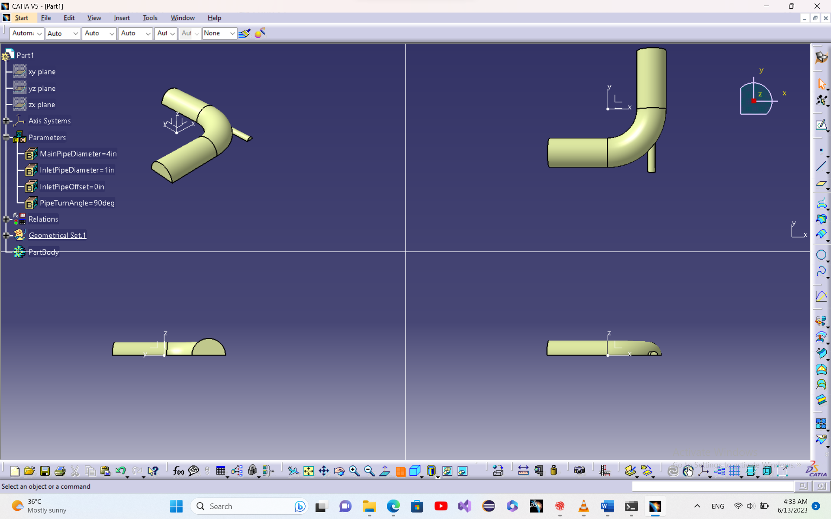

Figure 18. Final Geometry using project values.

# Analysis

### Importing model

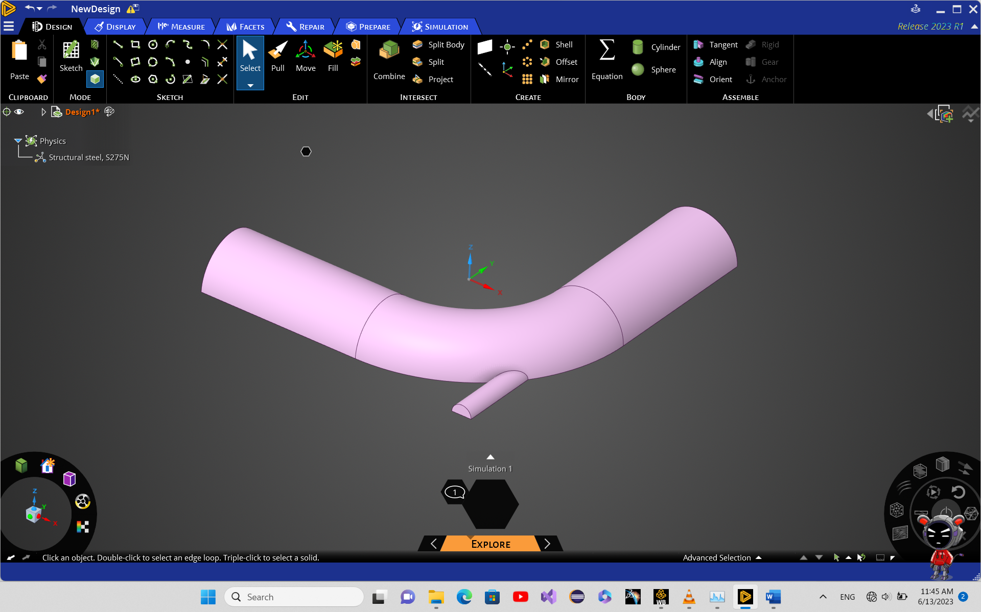

Figure 19. 3D model imported in Ansys Discovery

The model is imported into a geometry schematic using existing cad model as “.igs” .

### Mesh

#### 1st mesh

The model is connected to mesh to generate mesh by Ansys Meshing.

Generating a mesh using default parameters results in a bad mesh.

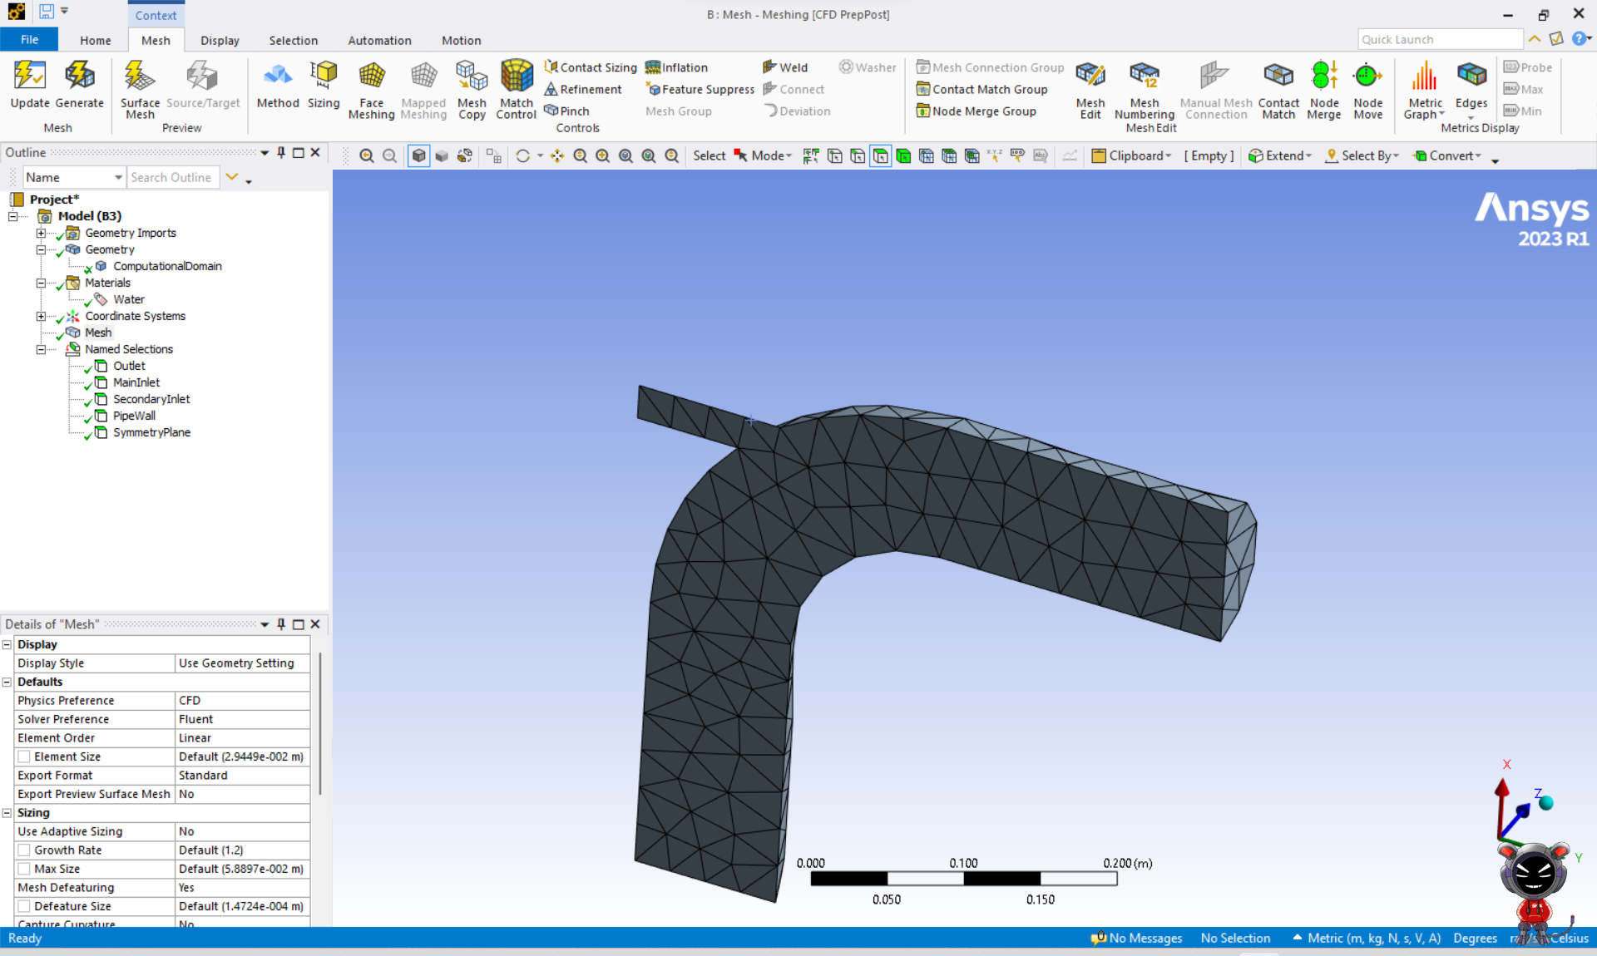

Figure 20. Default mesh in Ansys Meshing

Mesh can be refined in specific areas. As we can expect more variations in curved areas, mesh in those areas can be refined by adding mesh sizing to curved edges.

Dividing curves into 35 divisions, the intersection edge into 30 and straight lines into 25 another mesh is generated.

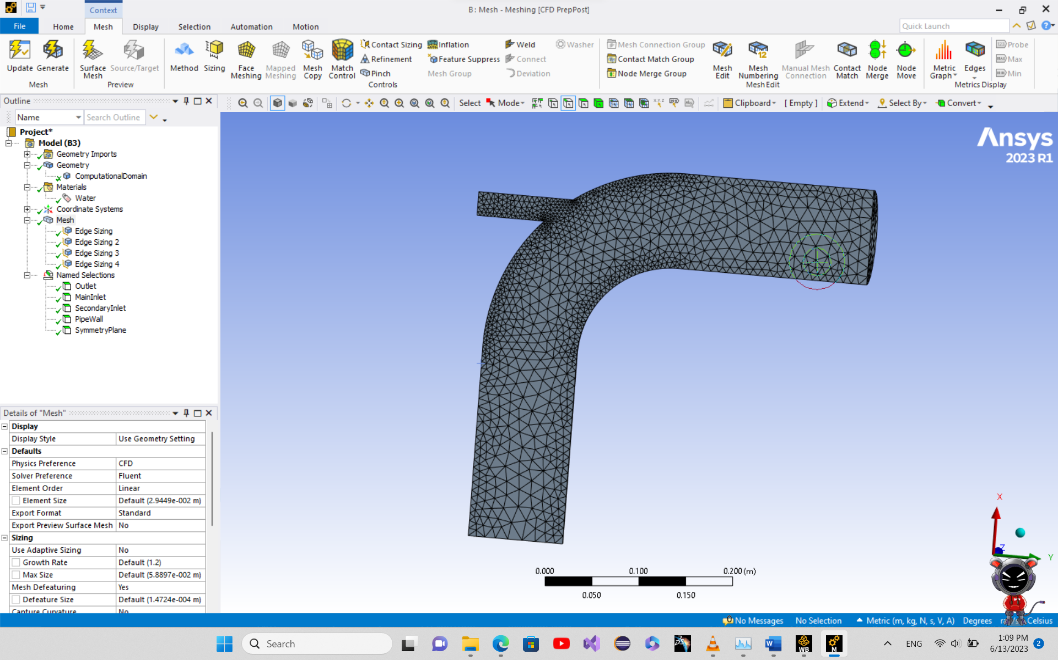

Figure 21. Mesh using edge size controls

Which captures the changes better. Still, meshes are too course so, another mesh size is added to the hole body 0.005m.

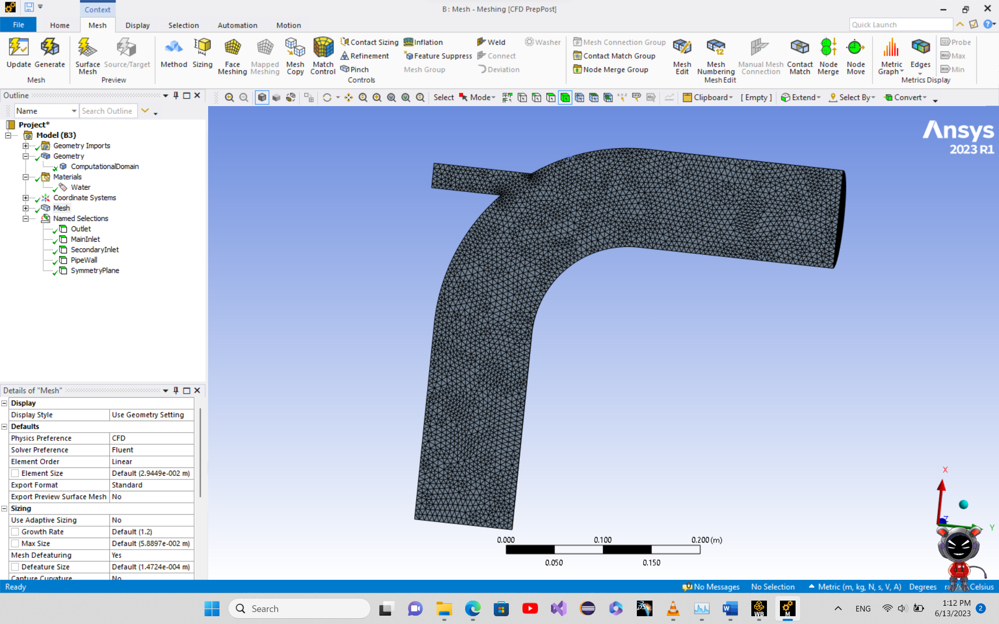

Figure 22. Mesh with body size control

In order to capture boundary layer and effects of it, another fine mesh is added around the walls.

Y+ is a dimensionless parameter that is a measure of distance from the first grid cell to the surface. The Y+ value determines the accuracy of the boundary layer thickness prediction. A value between 1 and 30 is considered appropriate for the simulation.

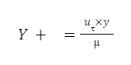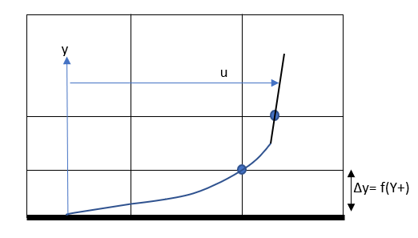

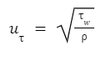

Using Y+ = 1 for the first grid cell size, the first layer thickness is 1.6e-5 m.

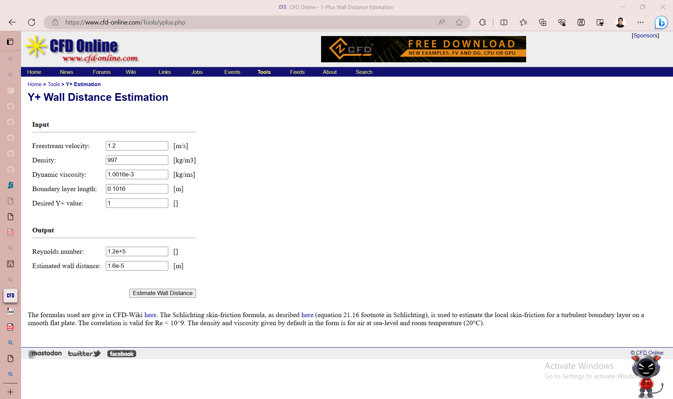

Changing “Maximum Layers” parameter until generated mesh covers the boundary layer.

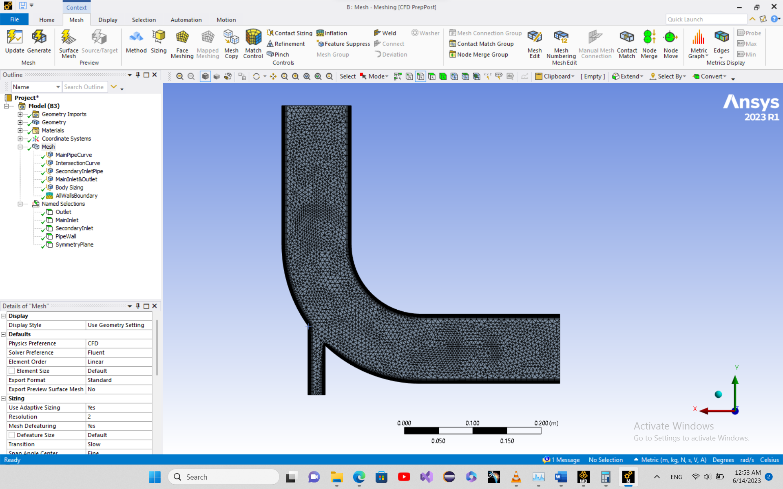

Figure 23. First mesh

This mesh is much better than default mesh with smaller meshes around the edges than other areas.

### Solve

Ansys solver has different numerical schemes. A quick comparison can be made.

Simple Solver: The Simple Solver is a pressure-based solver that is commonly used for steady-state, incompressible, laminar flows. It uses a segregated approach to solve the momentum equations and the pressure equation separately. The Simple Solver is less computationally expensive than other solvers but may not be as accurate and stable for some complex flows.

Simplec Solver: The Simplec Solver is an extension of the Simple Solver and is commonly used for steady-state, incompressible, turbulent flows. It uses a similar segregated approach as the Simple Solver but includes a correction term to account for the non-linear terms in the momentum equations. The Simplec Solver is more accurate than the Simple Solver for turbulent flows but may still have convergence issues for some complex flows.

PISO Solver: The PISO (Pressure-Implicit with Splitting of Operators) Solver is a pressure-based solver that is commonly used for steady-state or transient, incompressible, turbulent flows. It uses a fully coupled approach to solve the momentum equations and the pressure equation simultaneously. The PISO Solver is more accurate and stable than the Simple Solver for turbulent flows but requires more computational resources.

Coupled Solver: The Coupled Solver is a more advanced solver that is commonly used for complex flows, such as fluid-structure interaction or conjugate heat transfer. It uses a fully coupled approach to solve the momentum equations, the energy equation, and the other transport equations simultaneously. The Coupled Solver is the most accurate but also the most computationally expensive solver.

Adding martials, Boundary conditions and other simulation parameters as the problem requires, the simulation can be run.

#### 1st Run

Solving by 500 iterations

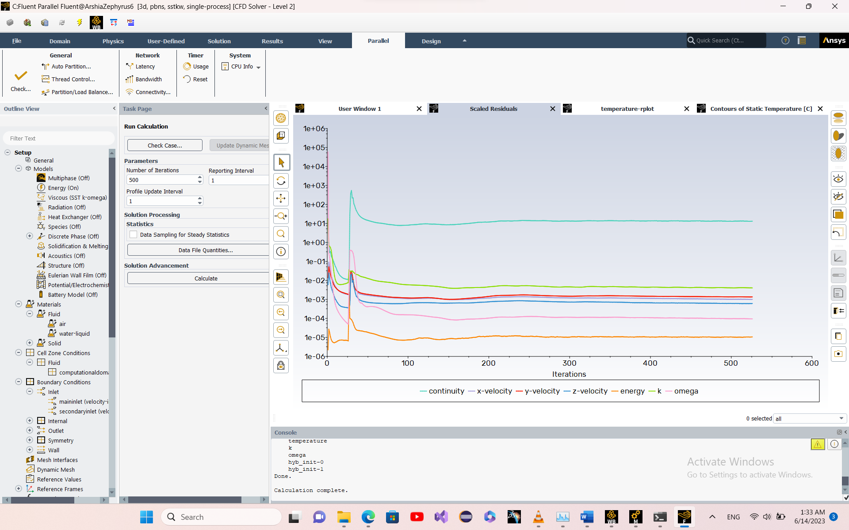

Figure 24. First run residual window

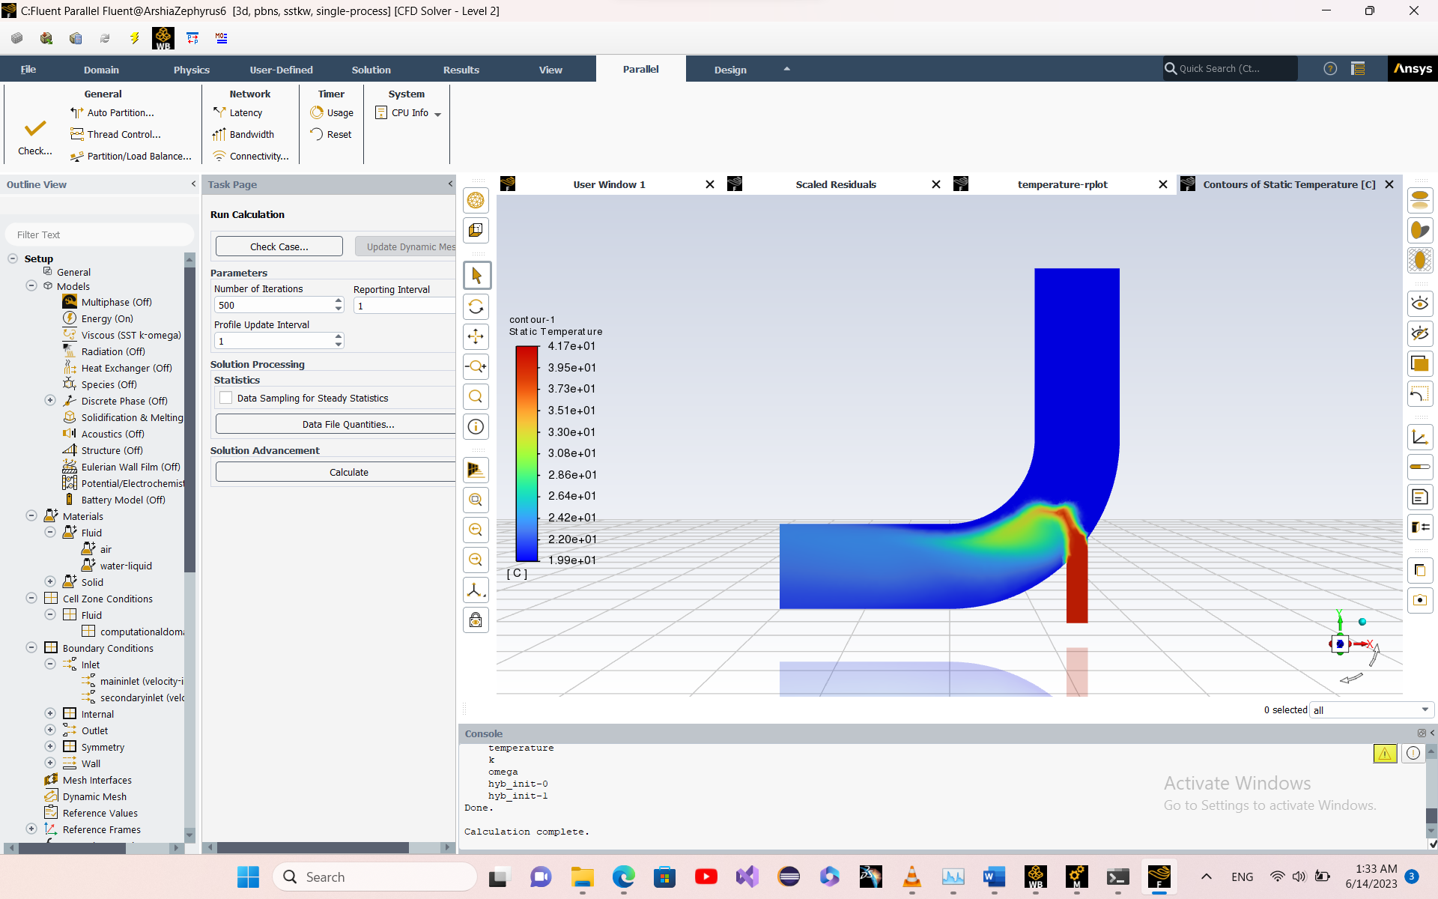

Figure 25. First run temperature contour

The solution is converged since the residuals remain constant but is quite high and the temperature contour looks unrealistic as it’s not a smooth mix.

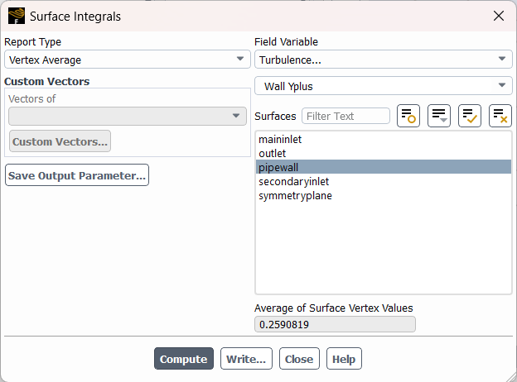

Figure 26. First run vertex average Y+ parameter

As explained in ANSYS classes, a Y+ < 1 means that the solution did capture the boundary layer.

#### 2nd Run

Rerunning using the same mesh but this time using “Coupled” scheme.

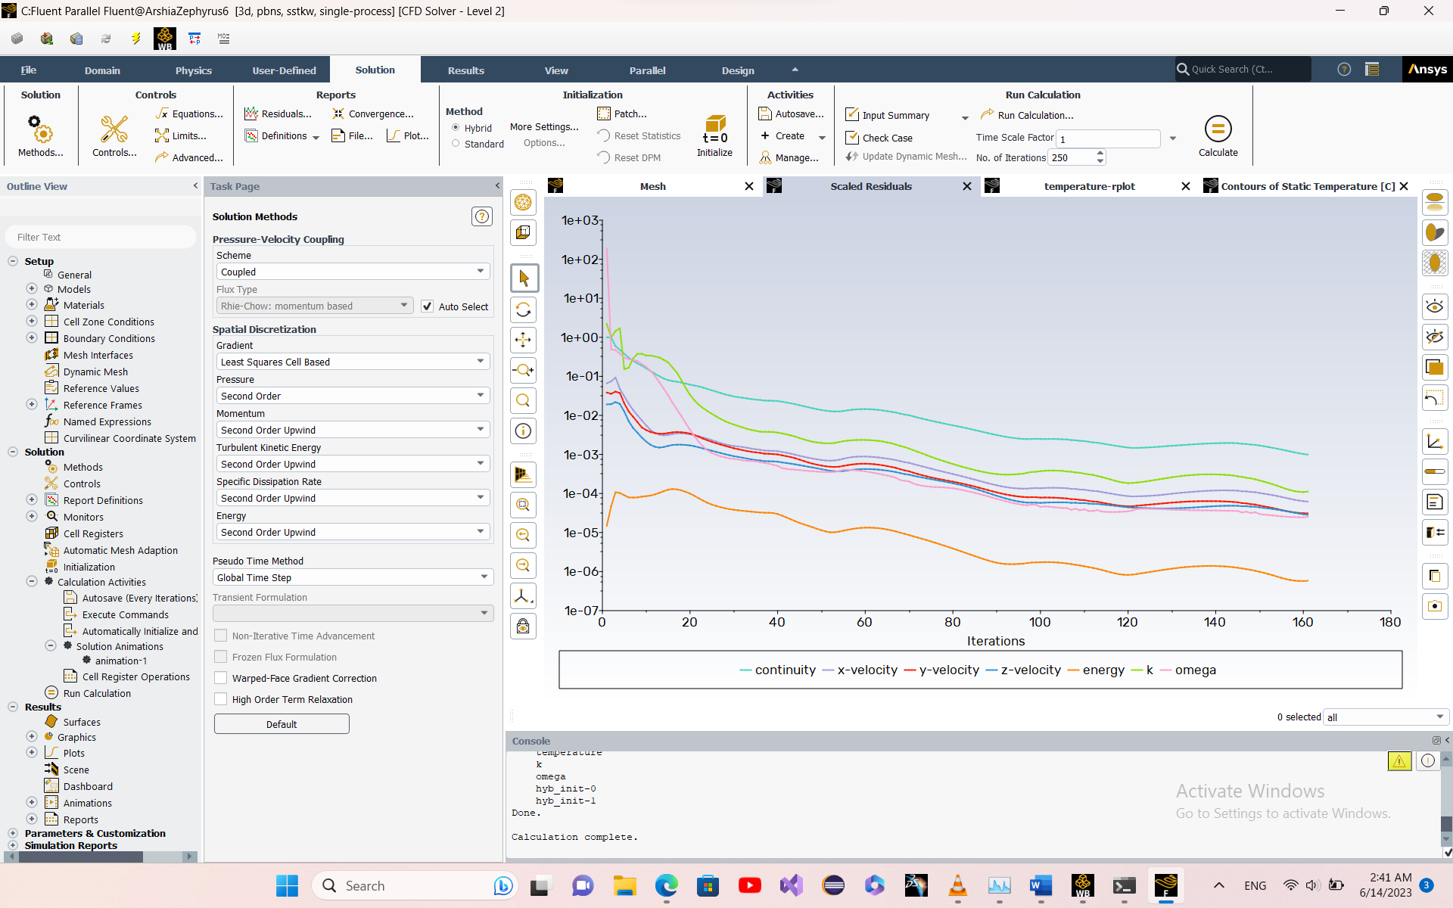

Figure 27. Second run residual window

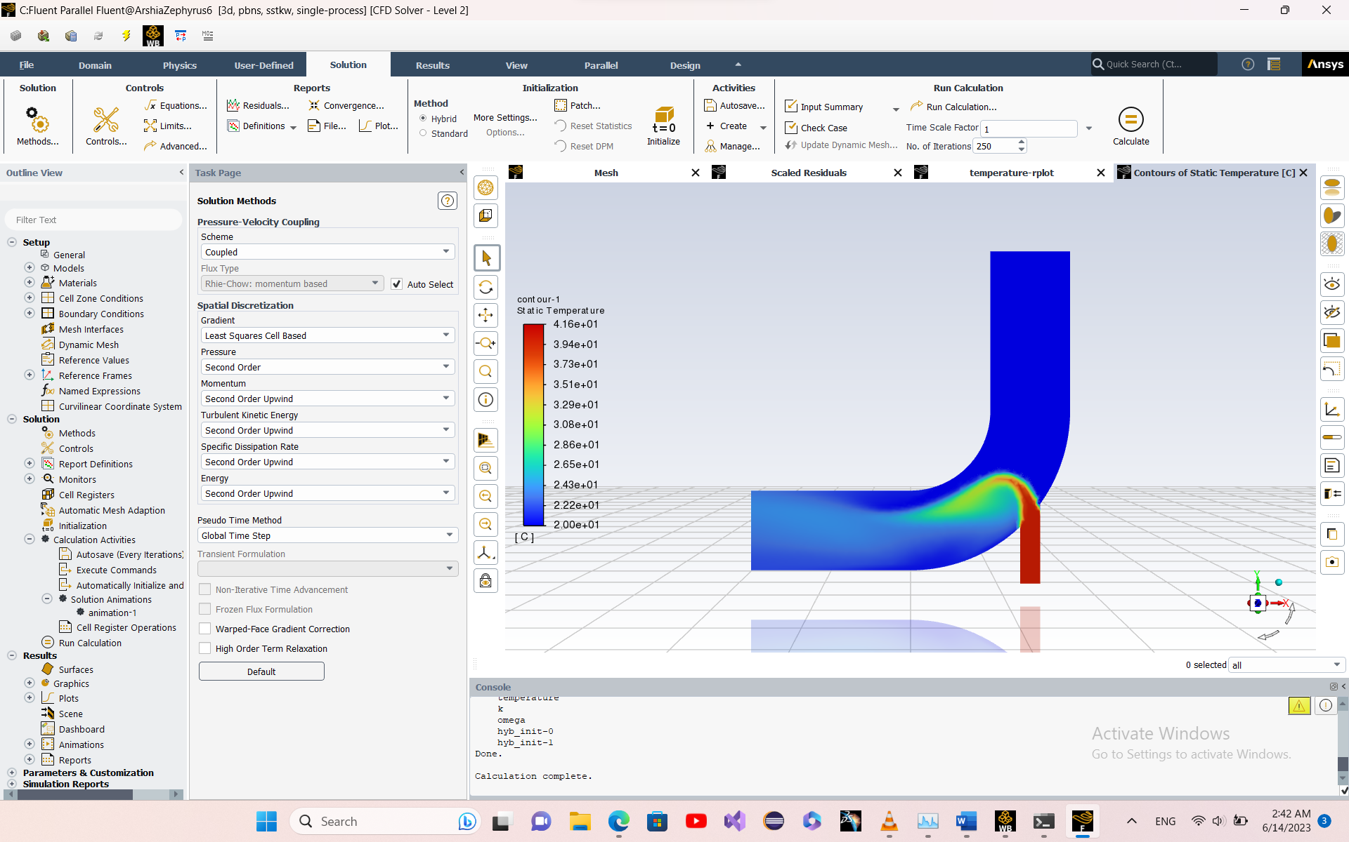

Figure 28. Second run temperature contour in symmetry plane

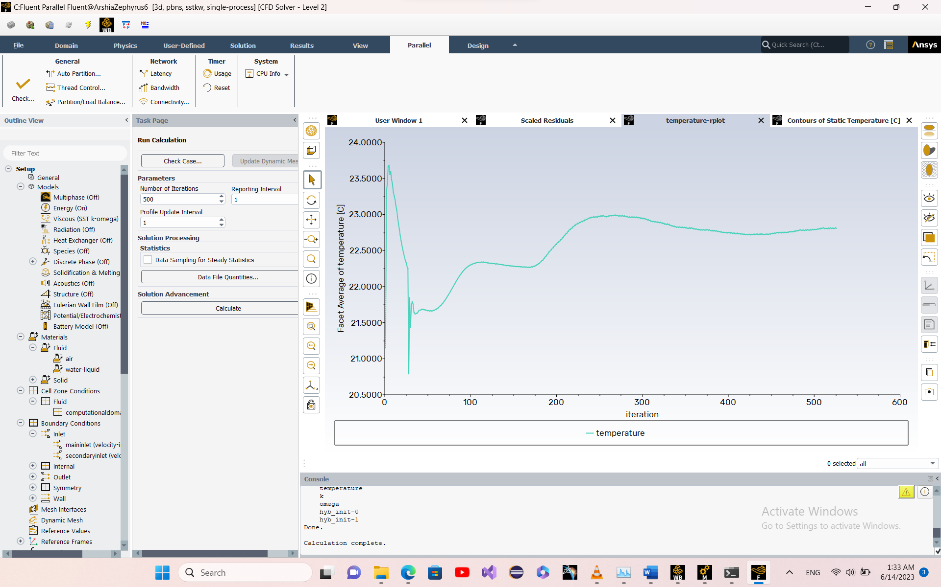

Figure 29. Second run outlet face average temperature

This method needed more time to converge. But seems like the mesh could be better as well.

#### Third run + 2nd mesh

This time, the mesh was generated by Ansys Discovery. Importing model and setting physics to water. Entering boundary condition and remeshing by Ansys Discovery.

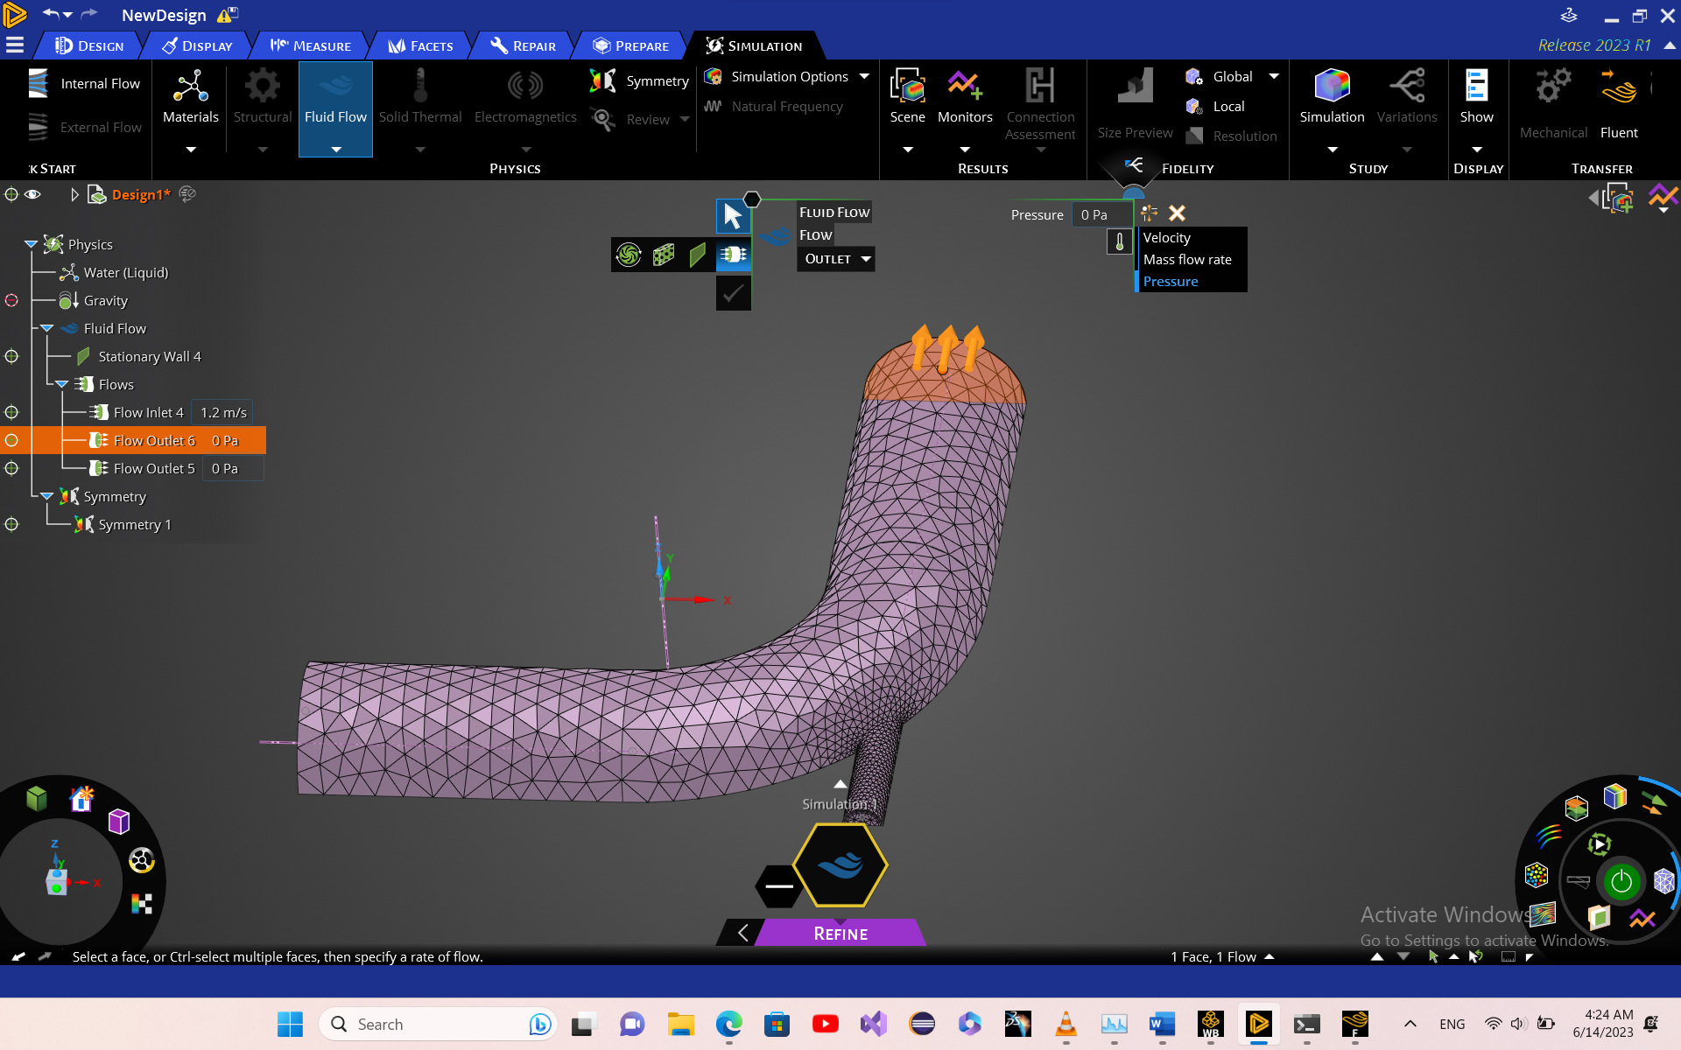

Figure 30. Ansys Discovery. Mesh and boundary conditions (the flows were corrected later in fluent)

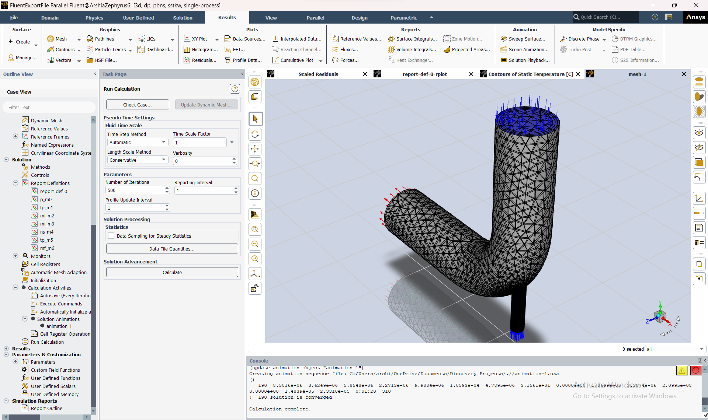

Figure 31. Third run mesh

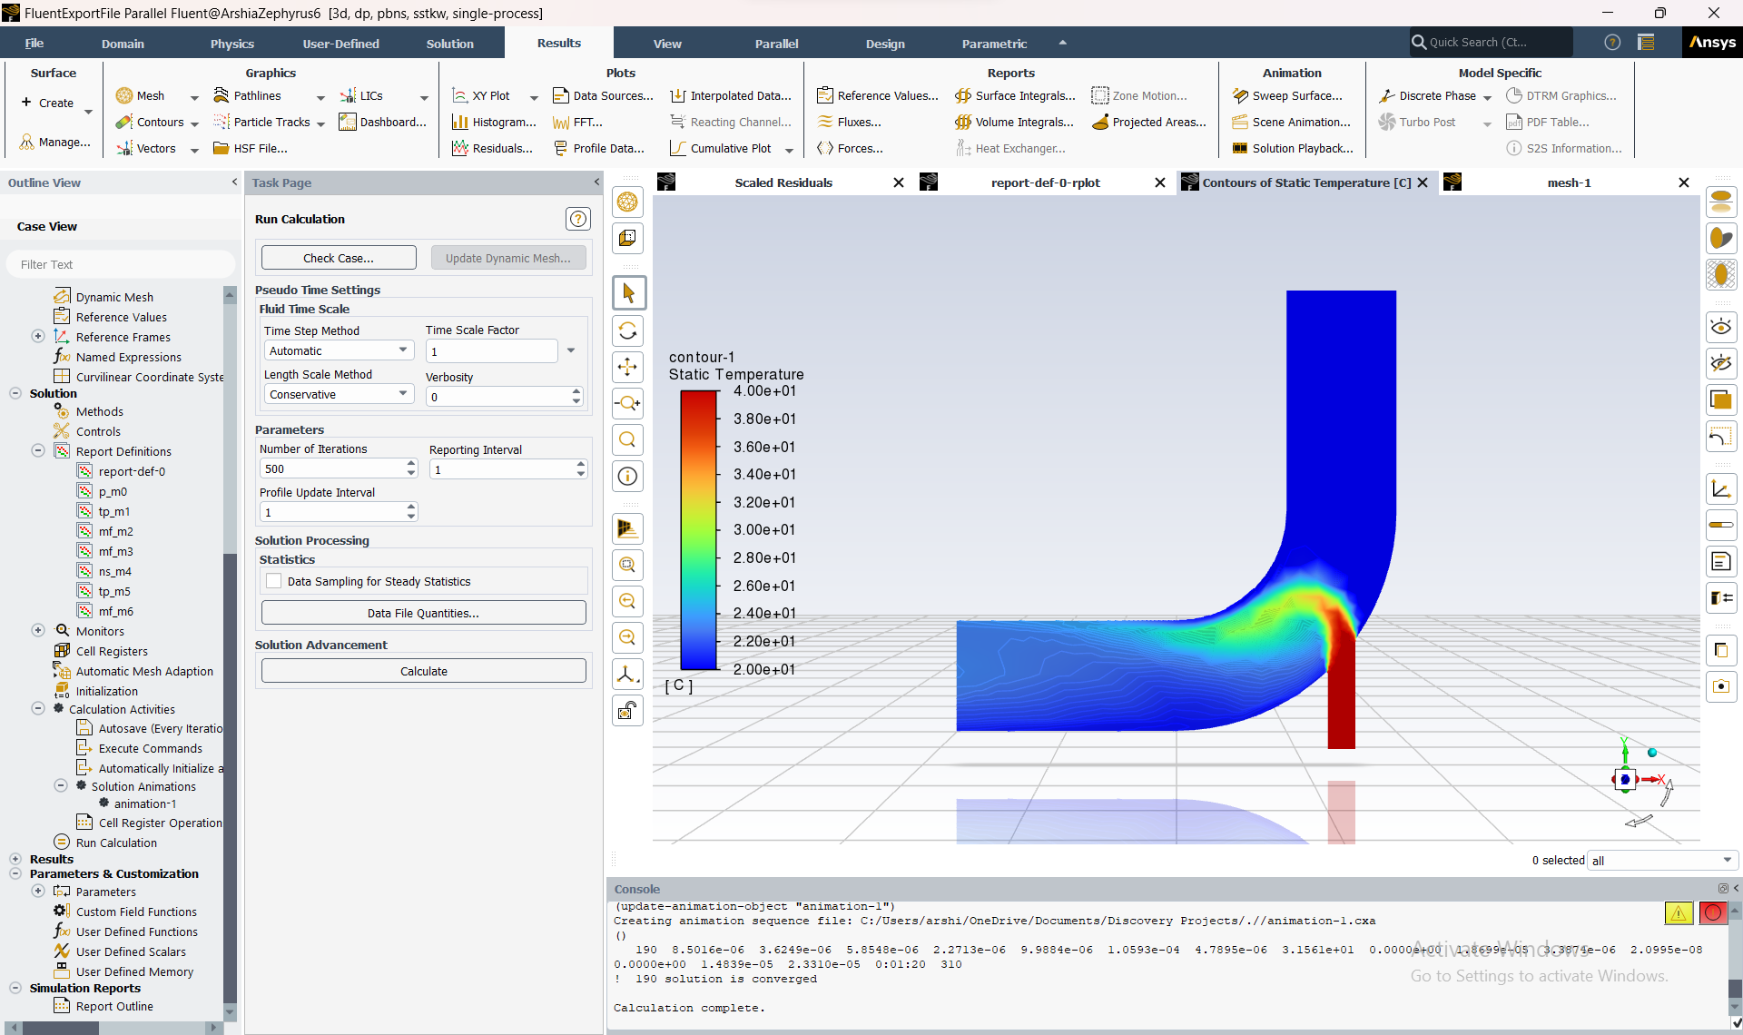

Figure 32. Third run temperature contour in symmetry plane

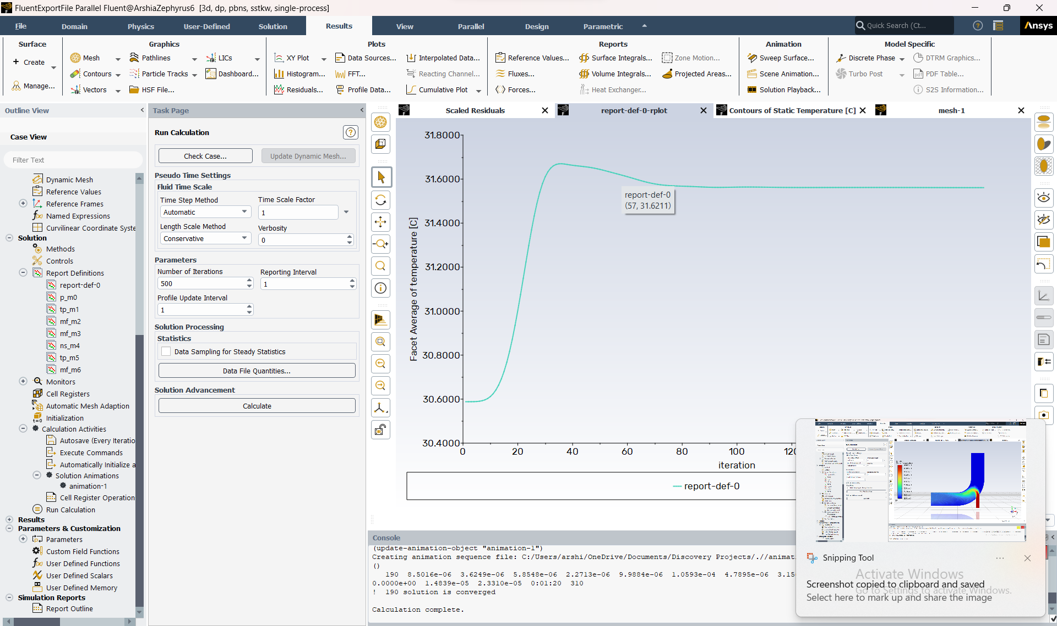

Figure 33. Third run outlet face average temperature

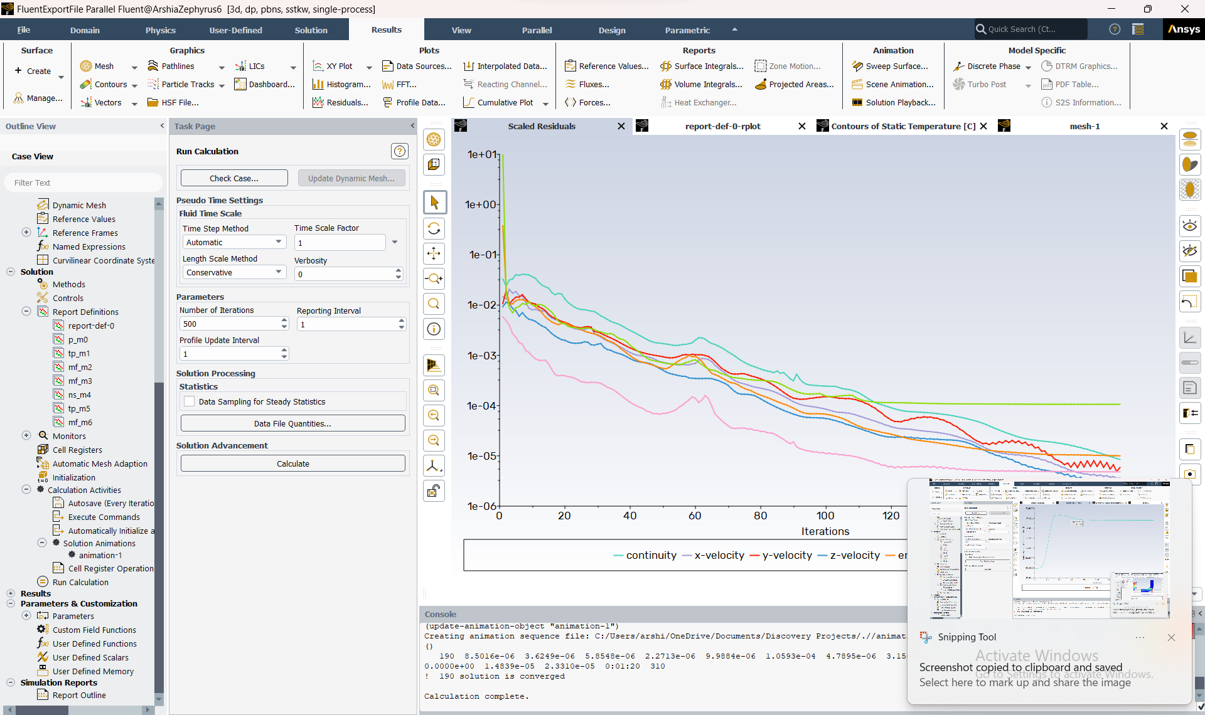

Figure 34. Third run residuals

The third run seems the best as residuals are least and average face temperature has converged. The temperature contour also looks fine.

The effect area in the third run is more than 2nd run. Also reinforcing the idea that 2nd run didn’t fully converge.

As the solution is accepted, other plots are generated.

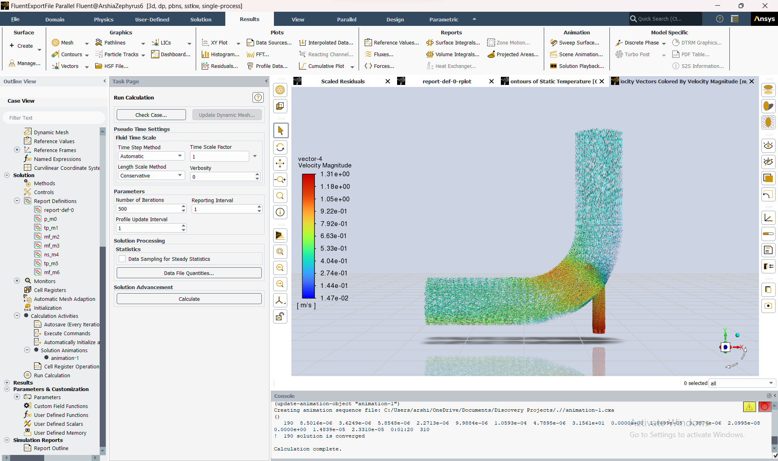

Figure 35. Third run interior velocity vectors.

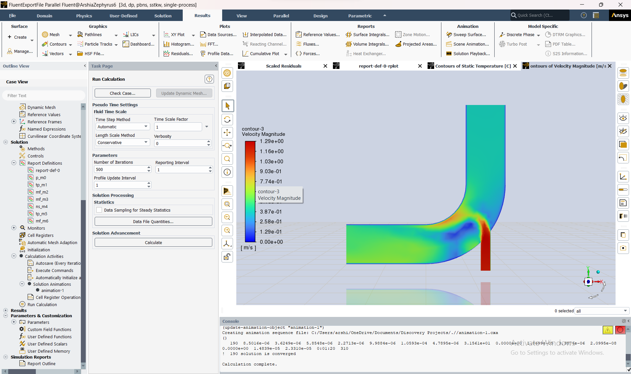

Figure 36. Third run velocity contour in symmetry plane.

Because of no slip condition, the wall velocity is zero. By looking at velocity vectors, weeks are formed in the middle of the pipe where turn is almost complete. As expected, the velocity in contour plot is low.

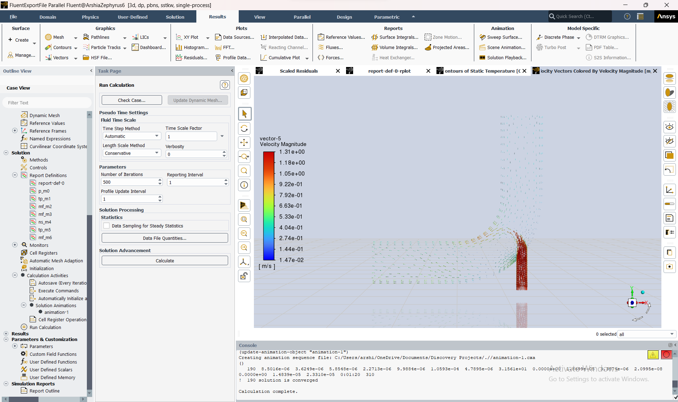

Figure 37. Third run velocity vector in symmetry plane

## Project Questions

What is Boussinesq approximation?

The Boussinesq approximation is a common assumption used in fluid dynamics to model the effects of buoyancy and density variations in incompressible flows. It is named after French physicist Joseph Boussinesq, who first proposed the approximation in the late 19th century.

In the context of T-shape pipe flow, the Boussinesq approximation is used to model the buoyancy forces that arise due to temperature or density differences in the fluid. It assumes that the density variations are small compared to the mean density of the fluid, and therefore the density can be treated as a constant except in the buoyancy term.

The Boussinesq approximation allows the Navier-Stokes equations to be simplified by neglecting the density variation in the momentum equation and including it only in the buoyancy force term. This approach reduces the computational cost of the simulation while still accounting for the effects of buoyancy on the fluid flow.

In ANSYS Fluent, the Boussinesq approximation is commonly used in simulations involving natural convection or other buoyancy-driven flows. It is implemented by adding a body force term to the momentum equation that represents the buoyancy force due to the density variation. The magnitude of this force is proportional to the density difference between the fluid and a reference density, typically the mean density of the fluid.

What solver is best appropriate?

The Coupled solver.

The Coupled solver is an advanced numerical scheme in ANSYS Fluent that solves the Navier-Stokes equations for fluid flows using a fully coupled approach. In this approach, the momentum equations, the energy equation, and other transport equations are solved simultaneously, which can significantly improve the accuracy and stability of the solution.

Compared to the Simple or Simplec solvers, the Coupled solver typically requires more computational resources and may take longer to converge. However, it can handle more complex flows and boundary conditions, such as fluid-structure interaction or conjugate heat transfer, where the interactions between different physics are important.

Accuracy: The Coupled solver is generally more accurate than the Simple solver, especially for complex flows. The coupled approach allows for more accurate modeling of the interactions between different physics and reduces the numerical errors associated with segregated solvers.

Stability: The Coupled solver is also more stable than the Simple solver for some flows. The fully coupled approach ensures a consistent solution across all equations and reduces the risk of numerical instabilities.

Convergence: While the Coupled solver may take longer to converge, it can converge to a better solution than the Simple solver for some flows. This is especially true for complex flows where the Simple solver may not converge or may converge to a suboptimal solution.